**PORTFOLIO**

**COMPUTER SCIENCE AND ENGINEERING**

Submitted by:

Name: YESHJEET DABAD

Registration number: 12406456

Roll No.: RK24CTA08

Section: K24CT

**Submitted to : Dr . JOSHVA RAJG**



**LOVELY PROFESSIONAL UNIVERSITY**

**DECLARATION**

I, Yeshjeet Dabad, a student of Bachelor of Technology under CSE discipline at Lovely Professional University, Punjab, hereby declare that all the information furnished in this project report is based on my own work and is genuine

YESHJEET DABAD

Registrartion Number: 12406456

|  |  |  |
| --- | --- | --- |
| Platforms for profile creation | Link to student profile | Screenshot |
| ***Figma*** |  |  |
| ***Quora*** | https://www.quora.com/profile/Yeshjeet-Dabad | 1 |
| ***Stack overflow*** | https://stackoverflow.com/users/26949855/yeshjeet-dabad | 1 |
| ***Hacker Rank*** | https://www.hackerrank.com/profile/yeshjeetdabad | 2 |
| ***Hacker Earth*** |  |  |
| ***Geeks for Geeks*** | https://www.geeksforgeeks.org/user/yeshjee29hw/ | 1 |
| ***LinkedIn*** | https://www.linkedin.com/feed/?trk=guest_homepage-basic_google-one-tap-submit | 1 |
| ***Github*** | https://github.com/YeshjeetDabad123 | 1 |
| ***Git*** |  |  |
| ***CV*** |  |  |
| ***MOOCS done*** |  |  |
| ***NON Technical MOOC PIC*** | AT THE END |  |

1.Linkedln

Profile:

Linkedln internal profile with project

Accomplishment:

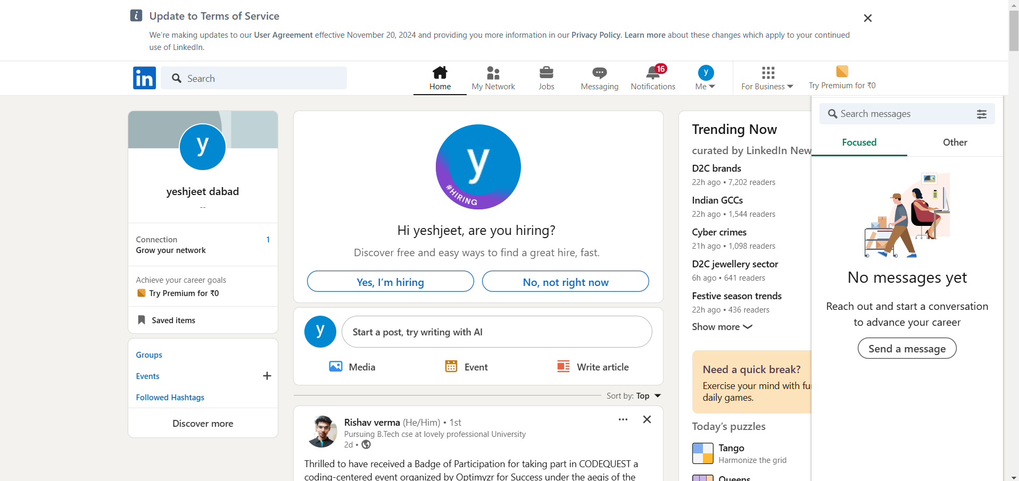

2.QUORA

PROFILE AND ACCOMPLISHMENT:

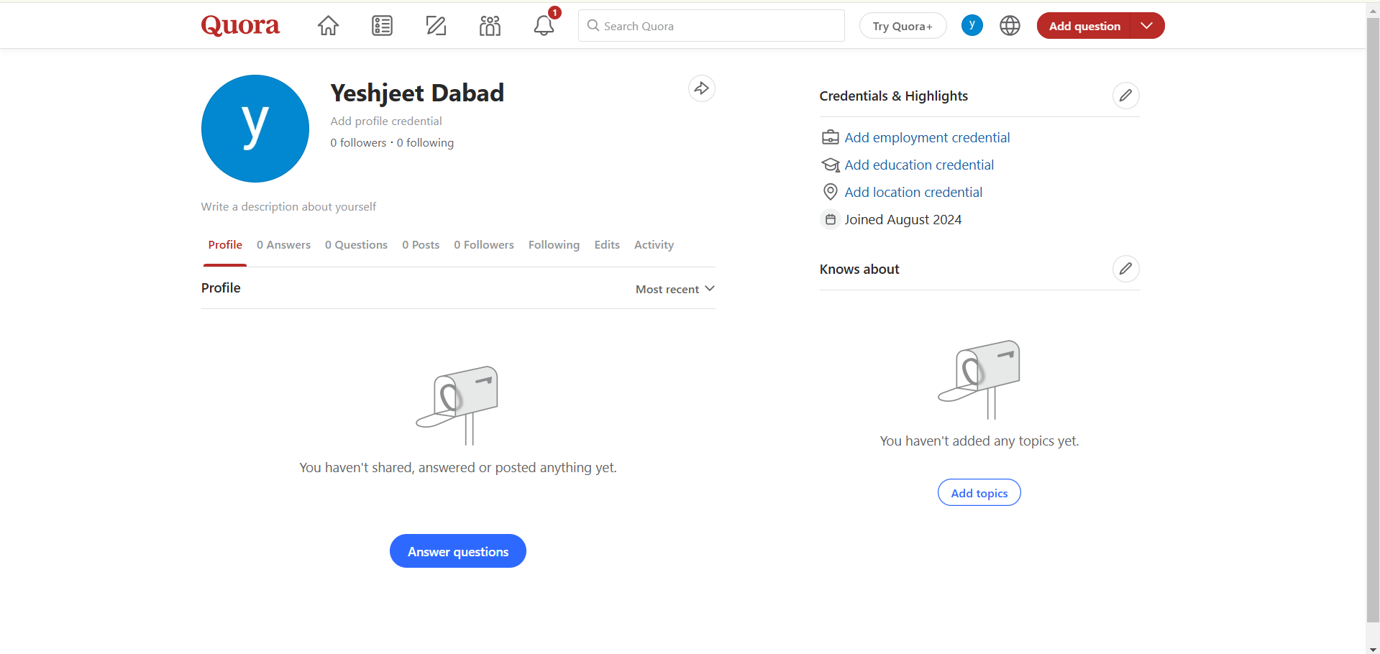

3.STACKOVERFLOW

PROFILE:

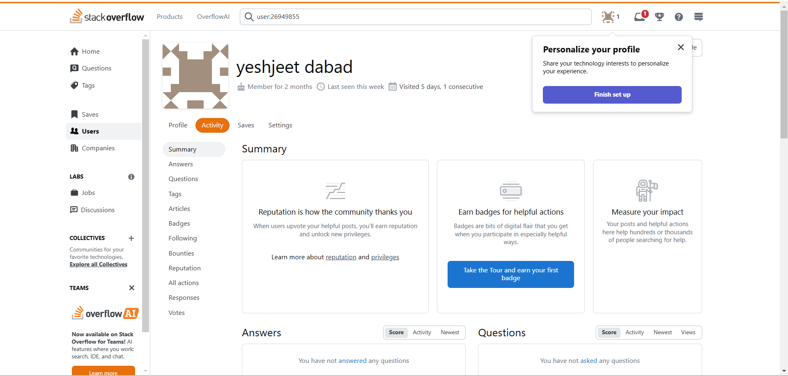

**4.HACKER RANK**

**Profile:**

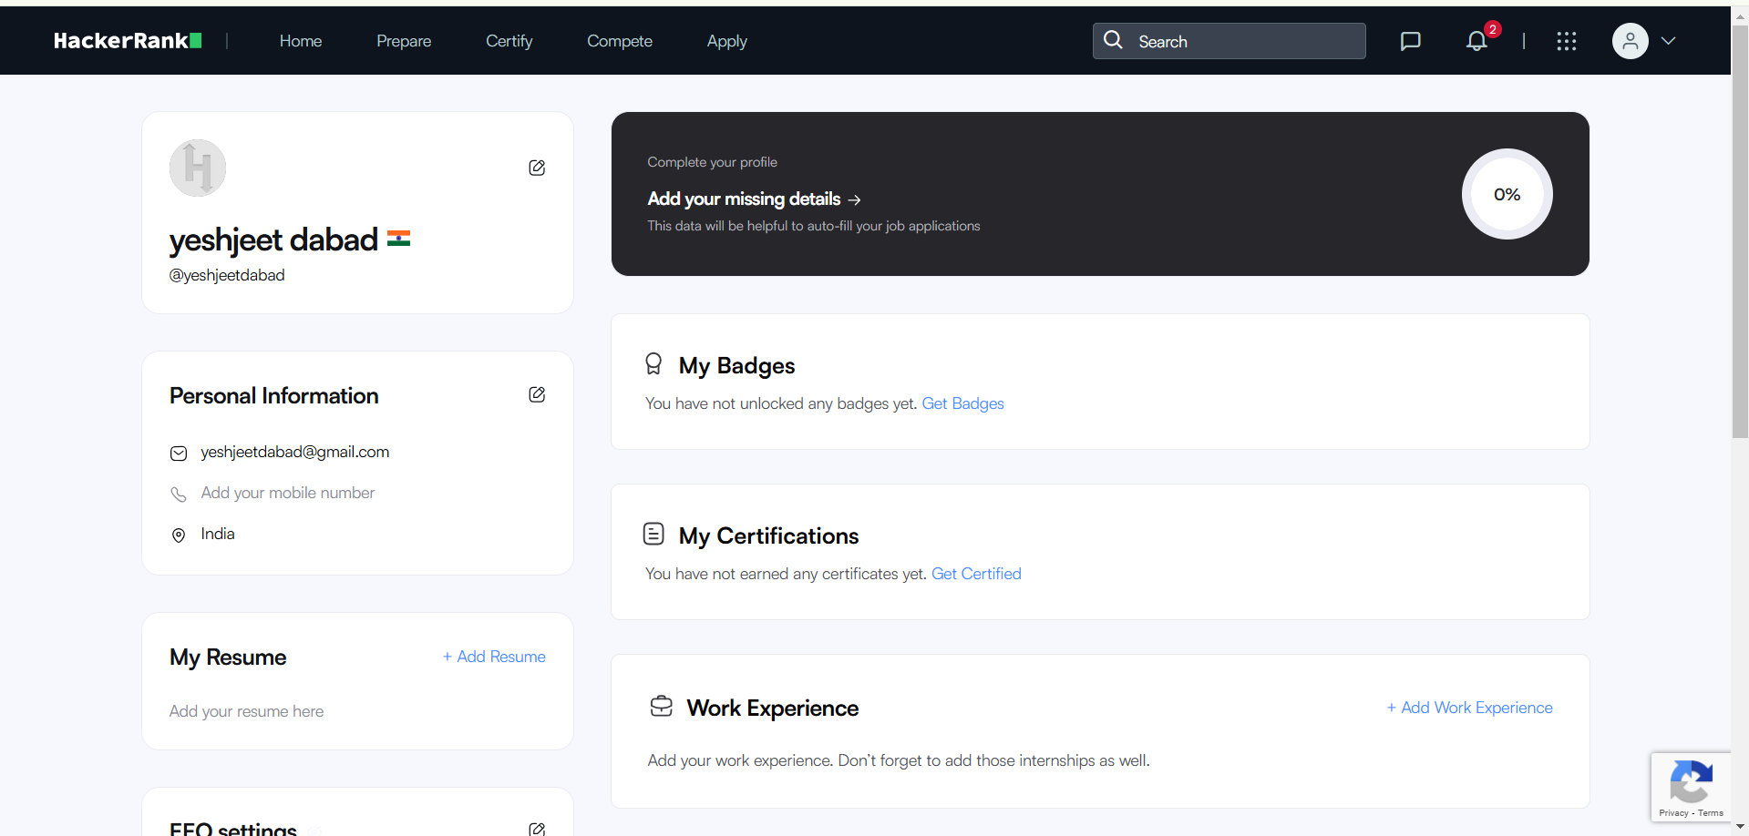

**5.GEEKS FOR GEEKS**

**Profile:**

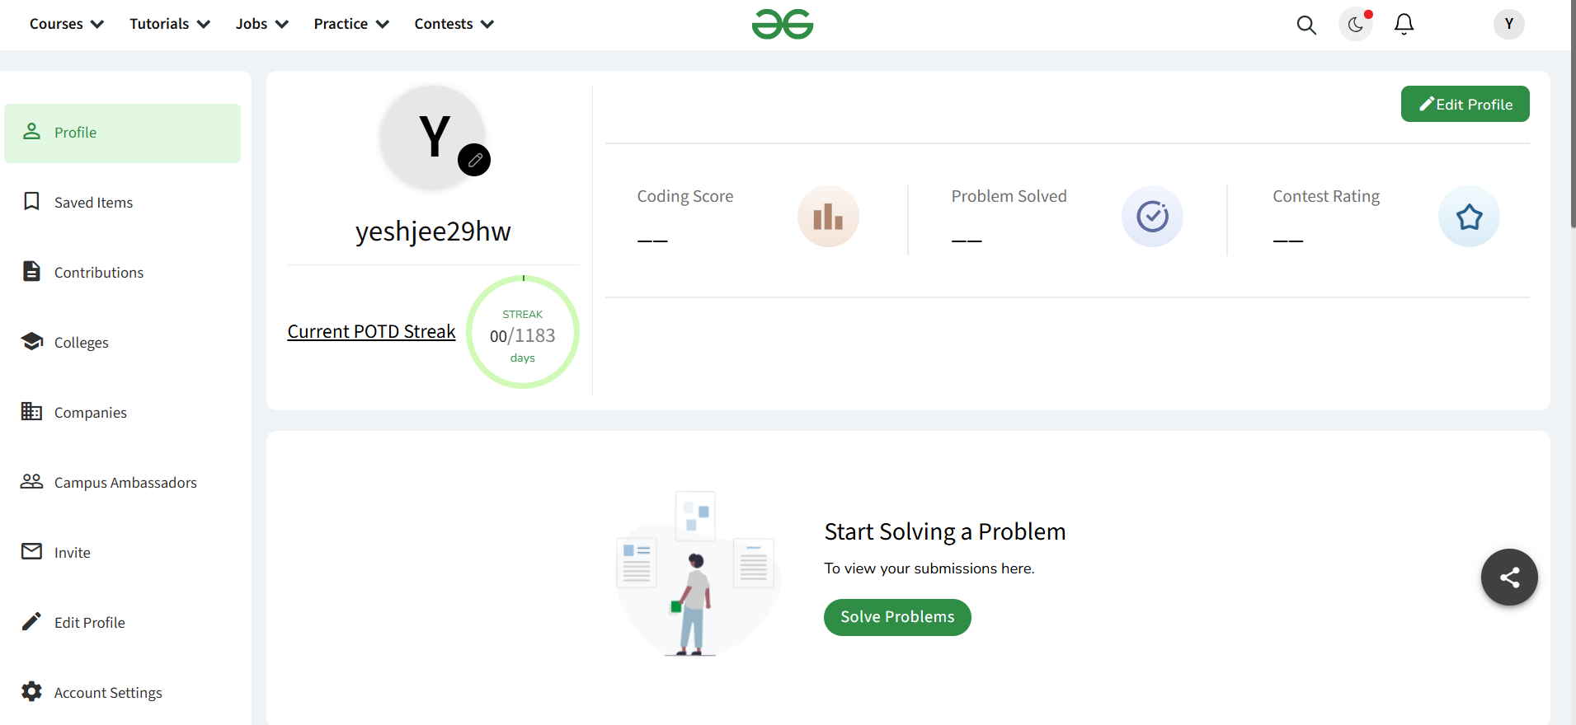

**6. GITHUB**

**Profile:**

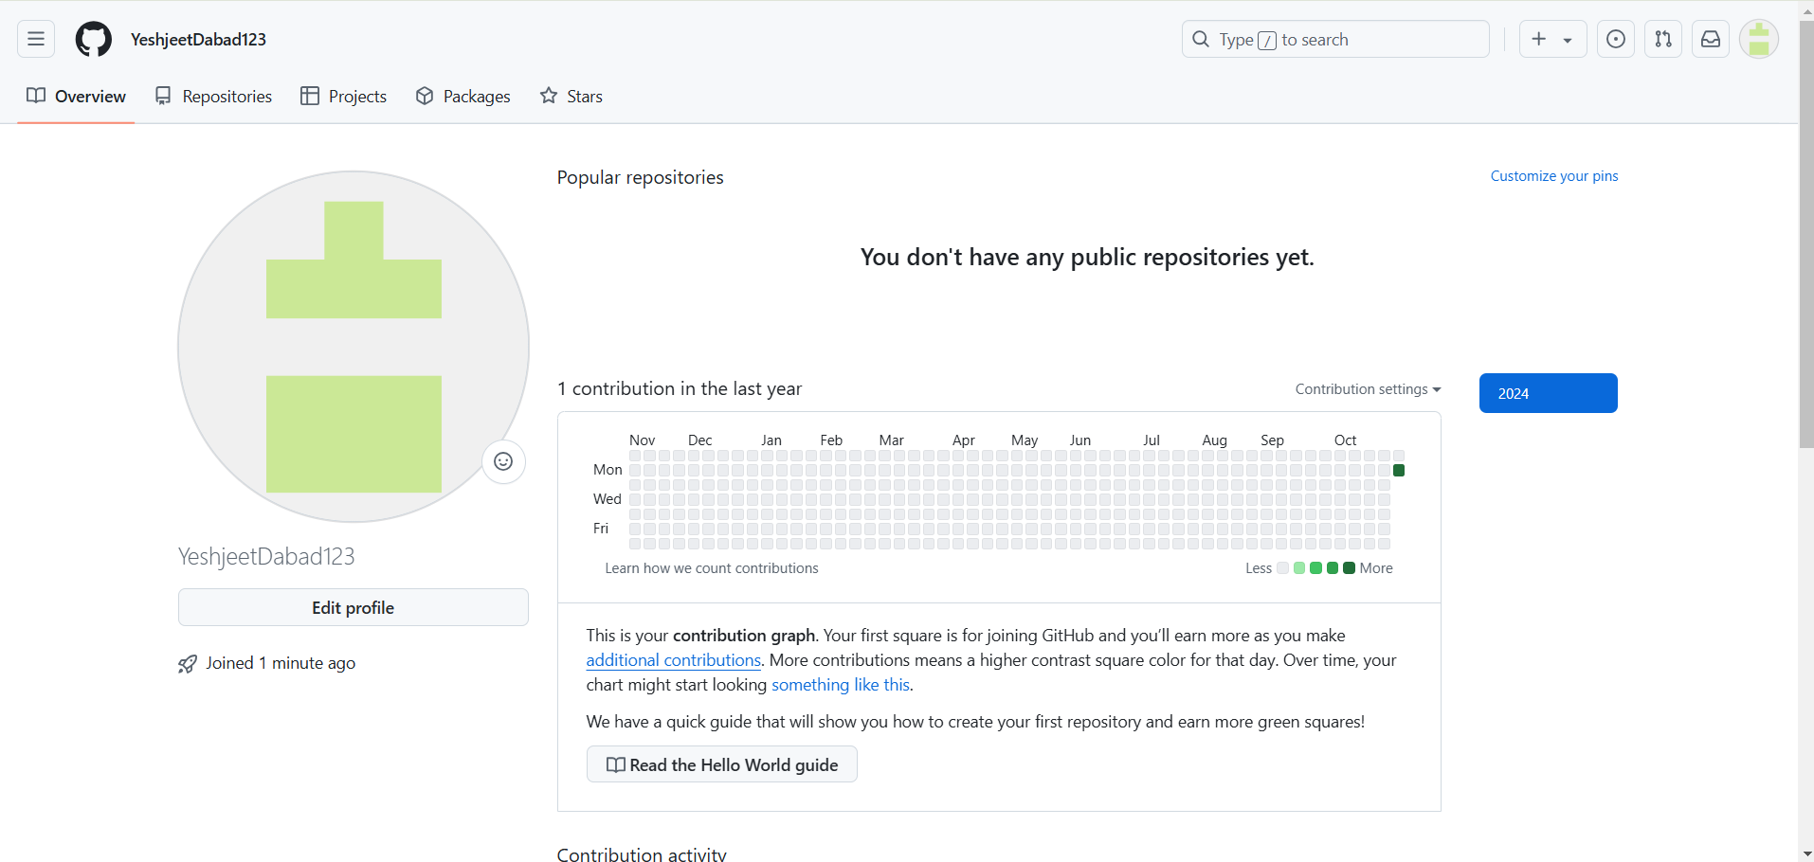

**10.CV**

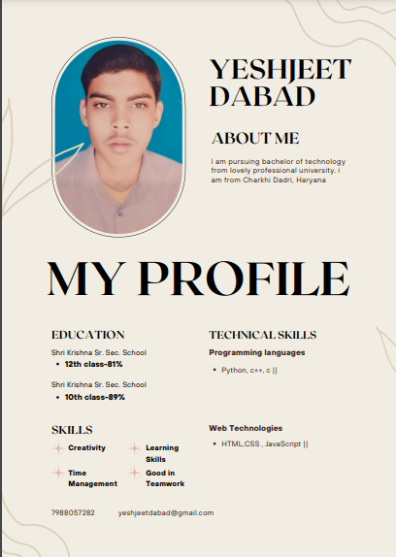

**11.MOOCS completed**

